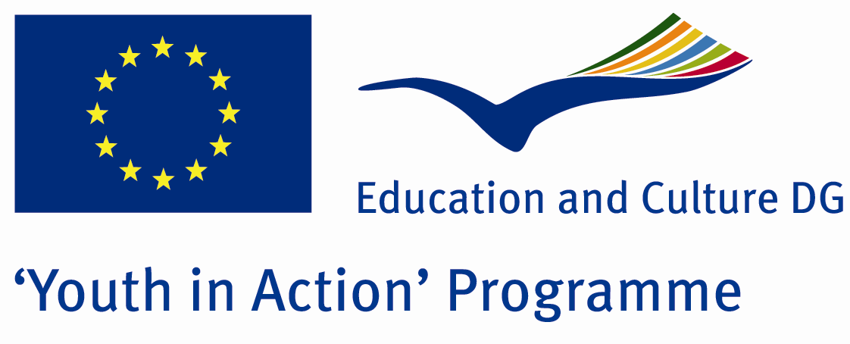

Unemployed Future



ACTION 4.3 – Training And Networking

28 July – 03 August, 2011

Burdur, TURKEY
ACTION 4.3 – Training And Networking
28 July – 03 August, 2011
Burdur, TURKEY

Please contact directly to;
adventurerpeacepigeons@gmail.com

Project Summary;

Nowadays in all over the world, unemployment has been rising day by day and it has threatened our future. When the youngsters who are well educated, after university, hasn’t found job, they let down…This disappoinment has broken down the youngsters’ physicological situation…So, youngsters has been agresif and nervous people…

Here in this Project, we try to learn how we can solve this problem..We try to understand their psyhological situation and we evaluate this situation in terms of our future.

If you want to join this Project, please contact with us.

Project Title; Unemployed Future

Date and Venue ; 28 July – 03 August, 2011, Burdur, Turkey .

Target Group ; Municipalities, City Councils and Non-Governmental organizations,
youth groups,culture and art groups,e.t.c

Participants ; 5 people from each country (over 18 -25 ). Totally 8 countries.

Conditions ; Accommodation, board and programme costs will be financed through European Commission Youth in Action Programme (Action 1.1). Travel costs will be reimbursed in 70% (APEX Tarrifs). Organizations from all 27 EU member countries plus Liechtenstein , Norway and Iceland are eligible to take part.

Working language: English

Organizer; Adventurer Peace Pigeons

How to apply: If you are interested, please send your Part III forms to
0090 216 494 39 98 by FAX please. (Fulfilled Part III which you can find in the attachment, of course signed and stamped) ..

Note: jpeg is not allowed..please send by fax…

Next step 2;
Original send via regular post to this address please:

Ertan DERİN
Öner İnşaat
Abdulhalik Renda Cd.
Parlar Sk. No:4 Pendik/İSTANBUL

If you have any questions you may contact with: adventurerpeacepigeons@gmail.com

Deadline for application; until 20 March 2011.

For Further information:
Contact Person
Ertan DERİN
Öner İnşaat
Abdulhalik Renda Cd.
Parlar Sk. No:4 Pendik/İSTANBUL

e-mail : adventurerpeacepigeons@gmail.com
Mobile : 0090 542 393 93 90
Fax : 0090 216 494 39 98

